Bash scripting -2
- Create a bash script to check if a directory is available or not.

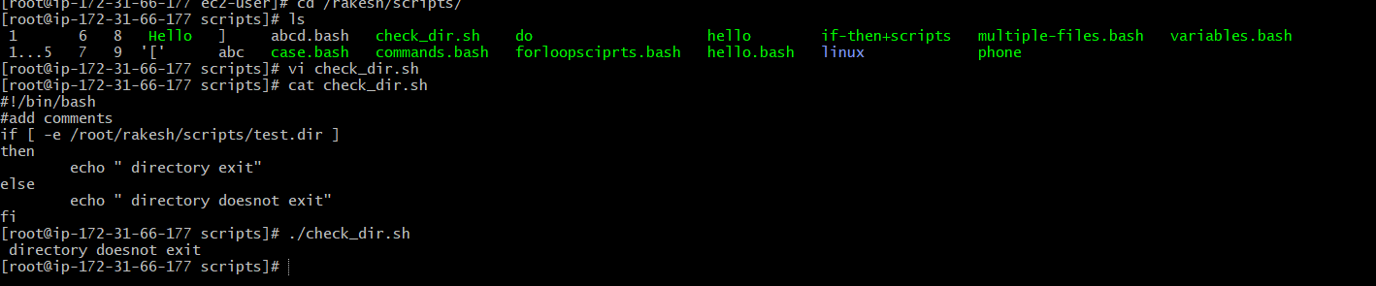
2.Create a bash script to create multiple files.
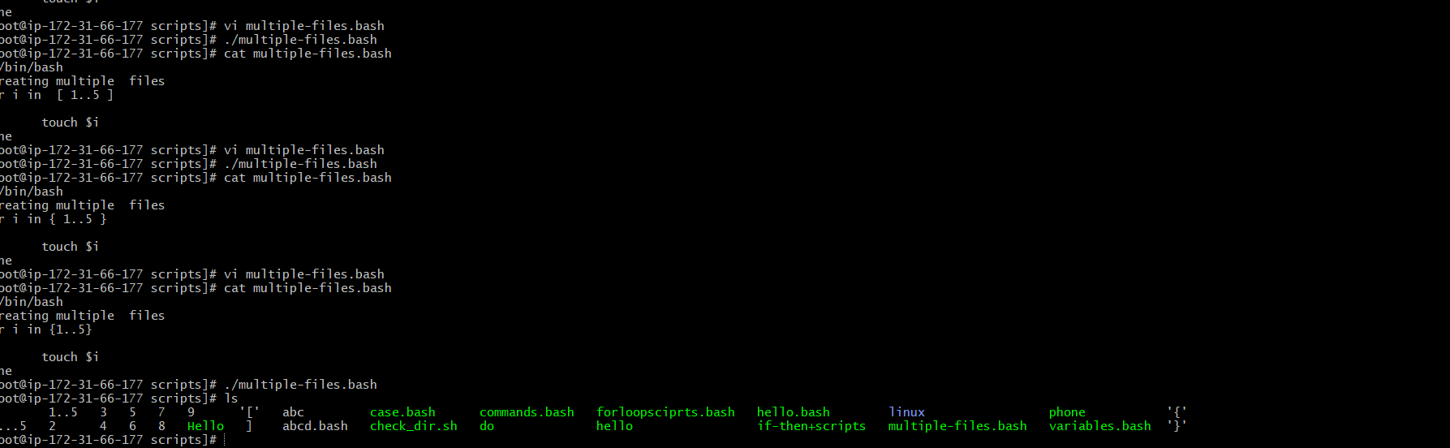

4. Create a bash script to install Nginx on an EC2 server
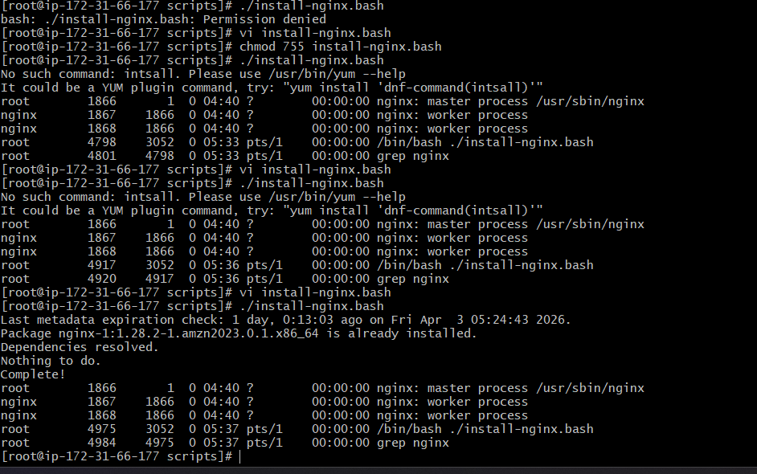

6.Create a bash script to install Apache Tomcat on an EC2 server.
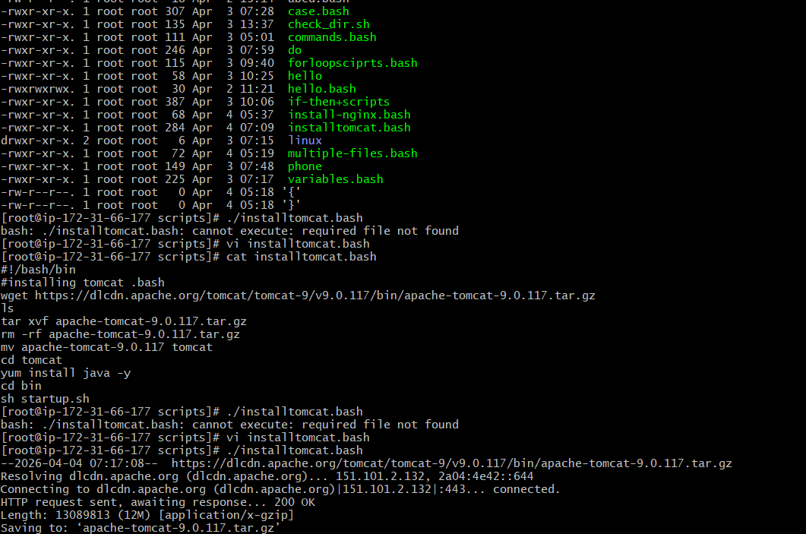
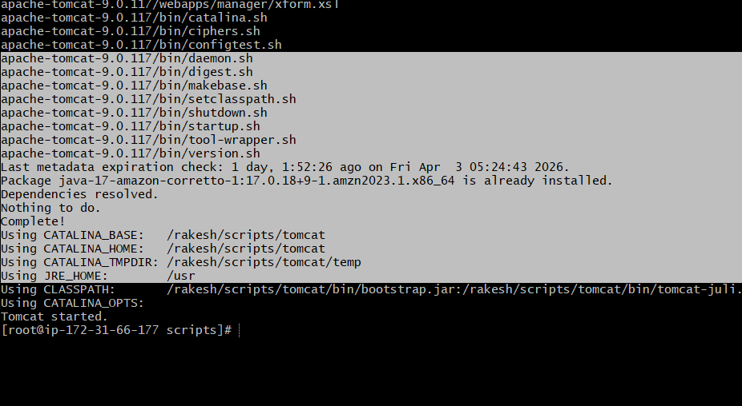

Create a bash script to check if the Nginx service is running, if not
running then script should start the service.
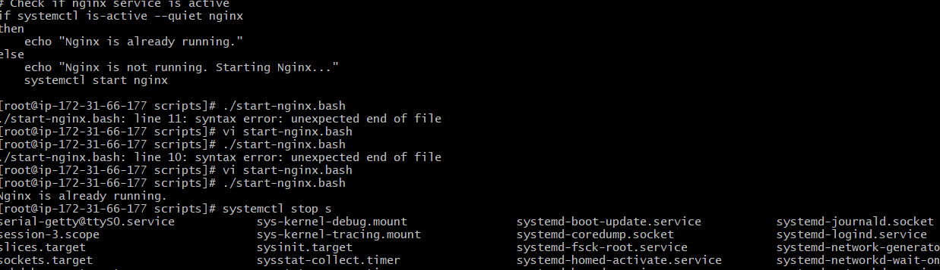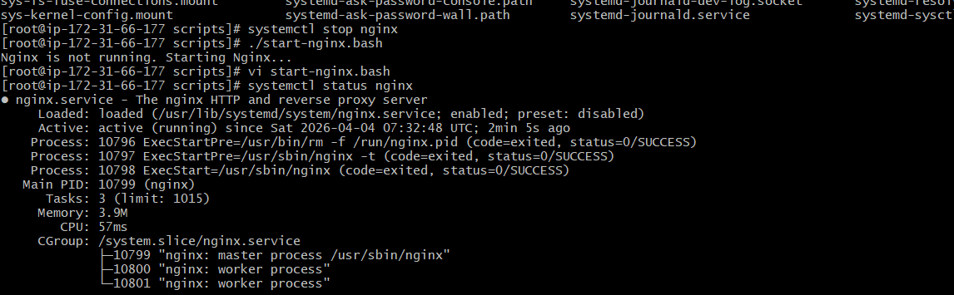

Create a bash script for a calculator.
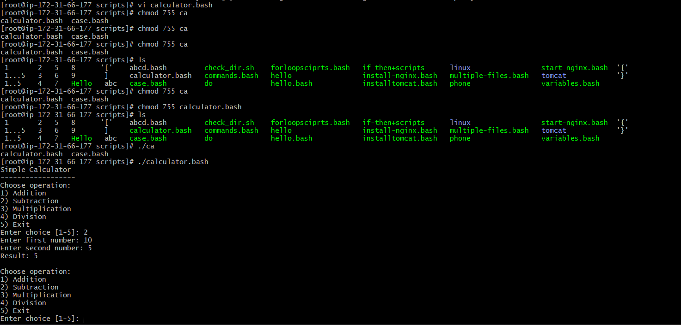Create a bash script to delete the last 3 lines of a file.
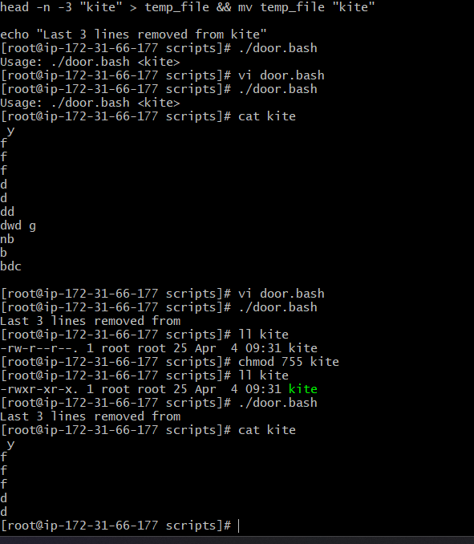
Bash script to monitor cpu and if it is more than 50% then send email
notification.
first we have to install mailx service and do some configuration on
/etc/mail.rc file
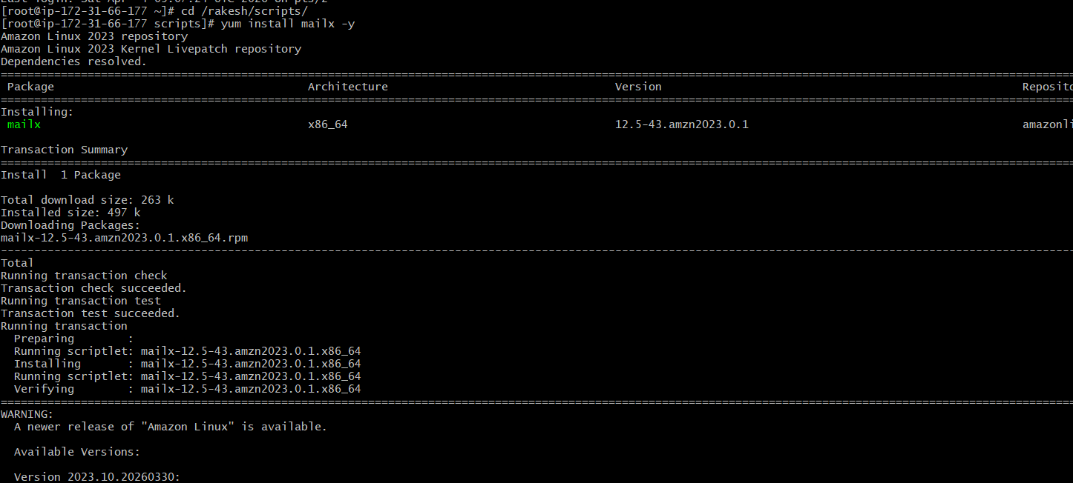
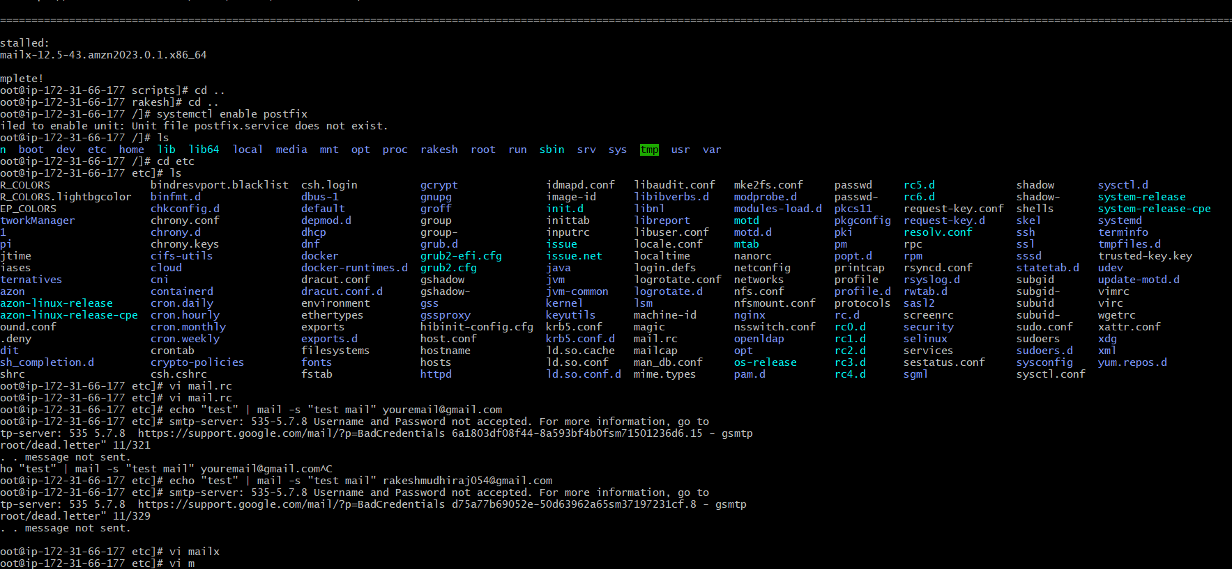

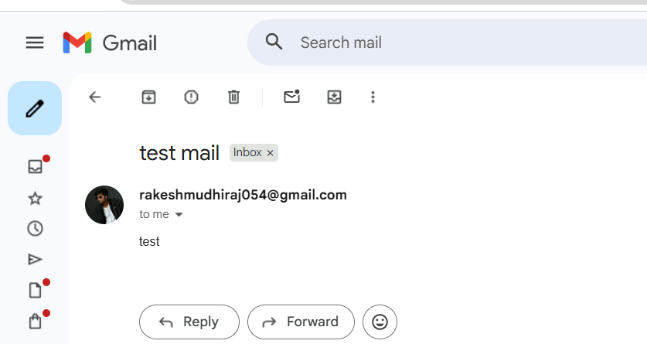
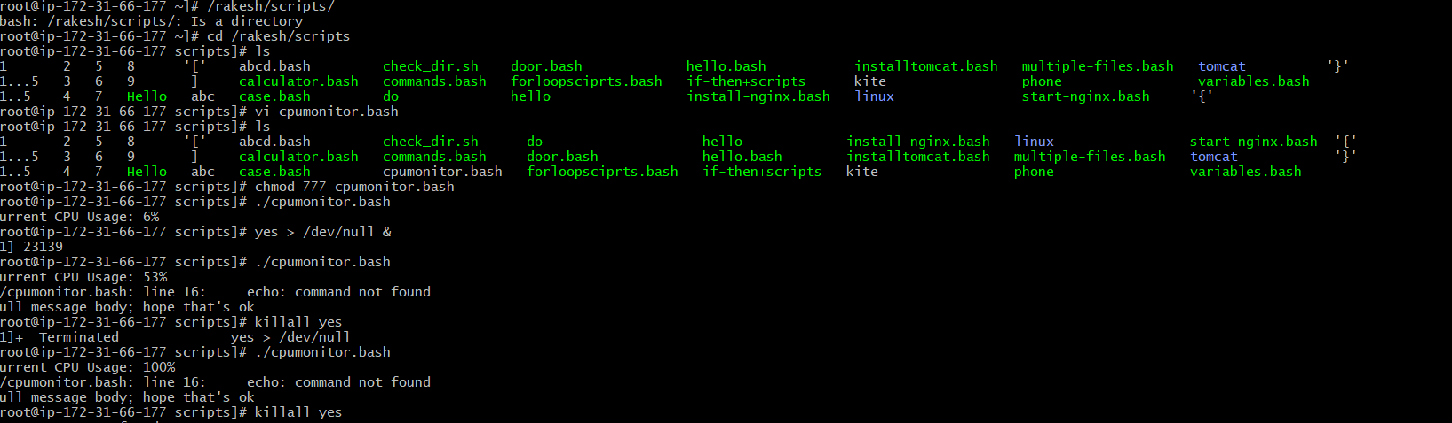
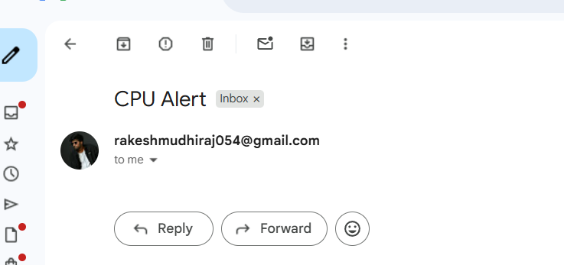

Bash script to monitor disk space and if it is more than 20% then
send email notification

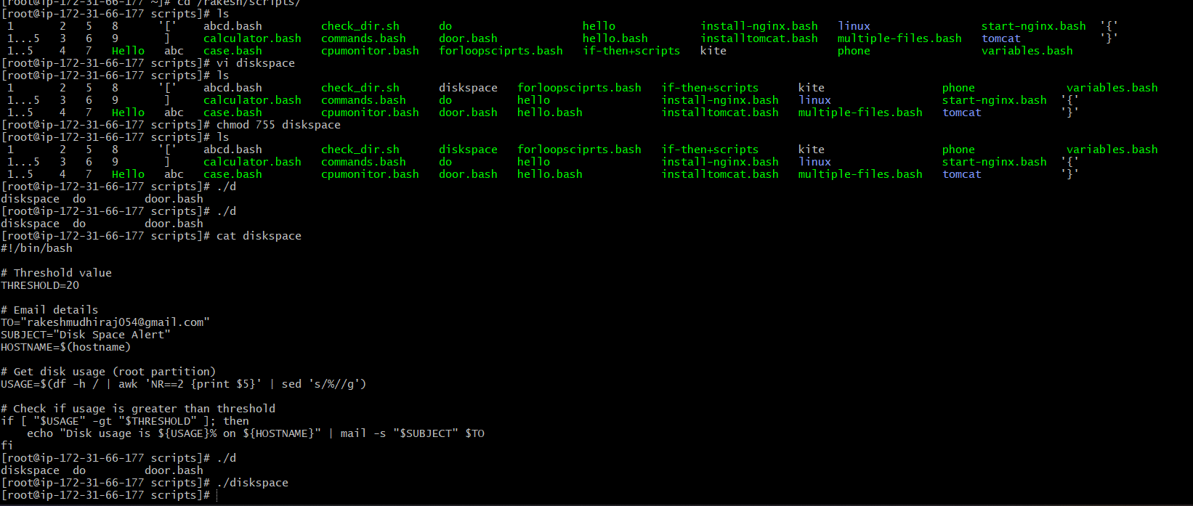

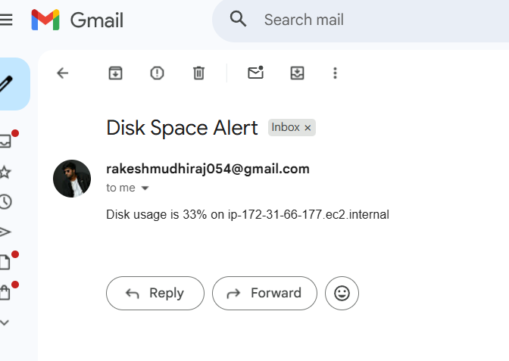

Bash script to monitor memory and if it is more than 30% then send
email notification.
